MINISTRY OF HEALTH
1448 NICOSIA

Annual Report on Minimum Data Set Injury Data Base (IDB-MDS)
October 2016

Analysis of all injury related attendances at Emergency Departments
(Period: 01/01/2013 – 05/10/2016)
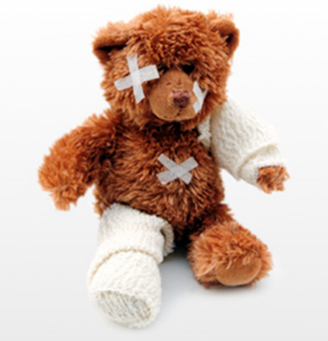

Prepared by: Maria Athanasiadou
Health Monitoring Unit, Ministry of Health

Number of injuries by emergency Department, 2013-2016 (Period: 01/01/2016 – 05/10/2016)
Hospital | Year of injury
 | 2013 | 2014 | 2015 | 2016 | 2013-2016 | % of total
Limassol | 14551 | 3519 | 8555 | 6908 | 33533 | 69%
Larnaca | 3390 | 2462 | 3092 | 1403 | 10347 | 21%
Pafos | 1453 | 3 | 70 | 1491 | 3017 | 6%
Polis | 248 | 406 | 268 | 172 | 1094 | 2%
Kyperounta | 85 | 104 | 316 | 160 | 665 | 1%
Total | 19727 | 6494 | 12301 | 10134 | 48656 | 100%

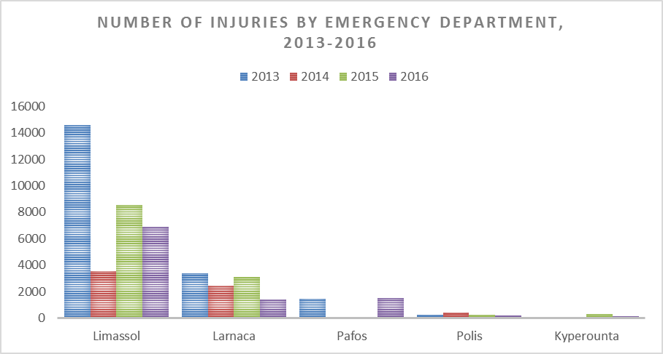

Injuries by Emergency Department, by year and month of injury, 2013-2016 (Period: 01/01/2013 – 30/09/2016)
Year / Month | Limassol | Larnaca | Pafos | Polis | Kyperounta | Total
2013 | 14551 | 3390 | 1453 | 248 | 85 | 19727
January | 1212 | 7 |  |  |  | 1219
February | 1205 | 231 | 372 |  |  | 1808
March | 1479 | 259 | 358 |  |  | 2096
April | 1391 | 300 | 307 |  |  | 1998
May | 1516 | 365 | 213 |  |  | 2094
June | 1388 | 380 | 113 |  |  | 1881
July | 1460 | 306 | 88 |  |  | 1854
August | 1285 | 371 | 2 | 93 | 41 | 1792
September | 1127 | 320 |  | 45 | 18 | 1510
October | 1078 | 281 |  | 29 | 5 | 1393
November | 785 | 308 |  | 46 | 7 | 1146
December | 625 | 262 |  | 35 | 14 | 936
2014 | 3519 | 2462 | 3 | 406 | 104 | 6494
January | 677 | 243 |  | 27 | 13 | 960
February | 677 | 171 |  | 22 | 7 | 877
March | 429 | 179 |  | 46 | 9 | 663
April | 436 | 160 | 1 | 35 | 11 | 643
May | 371 | 197 |  | 39 | 9 | 616
June | 121 | 224 | 1 | 35 | 7 | 388
July | 140 | 202 |  | 50 | 13 | 405
August | 134 | 266 | 1 | 48 | 8 | 457
September | 106 | 230 |  | 25 | 2 | 363
October | 199 | 201 |  | 35 | 12 | 447
November | 128 | 172 |  | 23 | 7 | 330
December | 101 | 217 |  | 21 | 6 | 345
2015 | 8555 | 3092 | 70 | 268 | 316 | 12301
January | 96 | 322 |  | 19 | 10 | 447
February | 156 | 254 |  | 17 | 9 | 436
March | 641 | 299 |  | 3 | 26 | 969
April | 374 | 264 |  | 25 | 22 | 685
May | 640 | 338 | 4 | 18 | 20 | 1020
June | 1011 | 252 |  | 33 | 21 | 1317
July | 998 | 294 |  | 39 | 50 | 1381
August | 957 | 250 | 21 | 46 | 58 | 1332
September | 1011 | 213 | 20 | 23 | 22 | 1289
October | 1062 | 219 | 9 | 18 | 21 | 1329
November | 863 | 165 | 7 | 13 | 25 | 1073
December | 746 | 222 | 9 | 14 | 32 | 1023
2016 | 6767 | 1383 | 1459 | 168 | 158 | 9935
January | 629 | 130 | 1 | 9 | 8 | 777
February | 621 | 136 | 96 | 10 | 17 | 880
March | 691 | 165 | 194 | 10 | 23 | 1083
April | 766 | 200 | 190 | 14 | 12 | 1182
May | 852 | 129 | 150 | 15 |  | 1146
June | 776 | 156 | 167 | 23 | 14 | 1136
July | 800 | 169 | 227 | 25 | 26 | 1247
August | 849 | 185 | 235 | 35 | 30 | 1334
September | 783 | 113 | 199 | 27 | 28 | 1150
Total | 33392 | 10327 | 2985 | 1090 | 663 | 48457
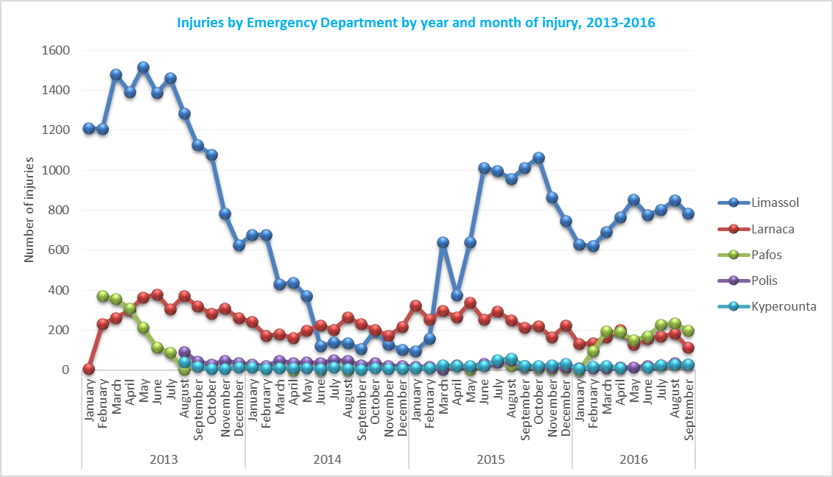

Injuries attended the Emergency Departments by age group, 2013-2016 (Period 01/01/2016 – 05/10/2016)
Age group | 2013 | 2014 | 2015 | 2016 | Total | % of total
0-4 | 1089 | 314 | 619 | 487 | 2509 | 5%
5-9 | 1071 | 342 | 610 | 499 | 2522 | 5%
10-14 | 1446 | 474 | 787 | 673 | 3380 | 7%
15-19 | 1924 | 596 | 1120 | 918 | 4558 | 9%
20-24 | 1932 | 640 | 1231 | 1008 | 4811 | 10%
25-29 | 1834 | 608 | 1121 | 922 | 4485 | 9%
30-34 | 1617 | 558 | 1098 | 842 | 4115 | 8%
35-39 | 1231 | 408 | 764 | 665 | 3068 | 6%
40-44 | 1118 | 371 | 669 | 579 | 2737 | 6%
45-49 | 965 | 328 | 659 | 502 | 2454 | 5%
50-54 | 1089 | 323 | 712 | 549 | 2673 | 5%
55-59 | 951 | 339 | 631 | 583 | 2504 | 5%
60-64 | 733 | 258 | 460 | 446 | 1897 | 4%
65-69 | 703 | 223 | 472 | 390 | 1788 | 4%
70-74 | 625 | 222 | 408 | 328 | 1583 | 3%
75-79 | 579 | 203 | 388 | 295 | 1465 | 3%
80-84 | 461 | 152 | 256 | 227 | 1096 | 2%
85+ | 326 | 111 | 241 | 175 | 853 | 2%
Not Stated | 33 | 24 | 55 | 46 | 158 | 0%
Total | 19727 | 6494 | 12301 | 10134 | 48656 | 100%

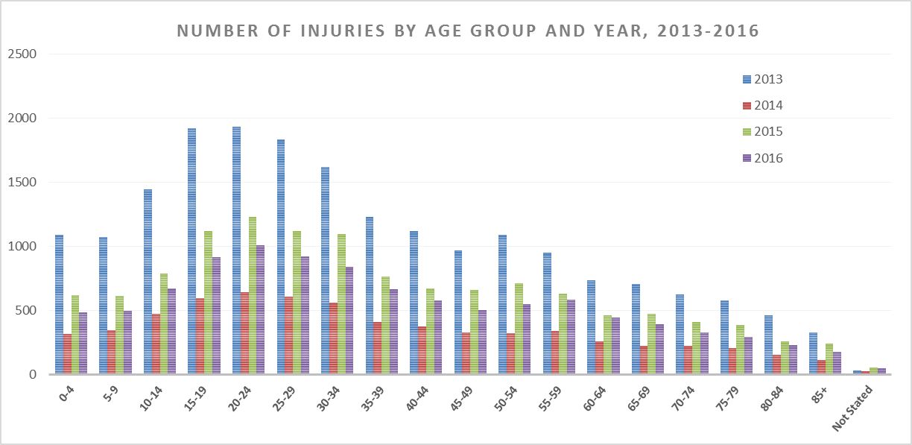

Injuries by sex and year, 2013-2016 (Period 01/01/2016 – 05/10/2016)
Year | Males | Females | Not Stated | Total
2013 | 12123 | 7599 | 5 | 19727
2014 | 4076 | 2417 | 1 | 6494
2015 | 7330 | 4964 | 7 | 12301
2016 | 6111 | 4023 |  | 10134
Total | 29640 | 19003 | 13 | 48656
% of row | 61% | 39% | 0% | 100%

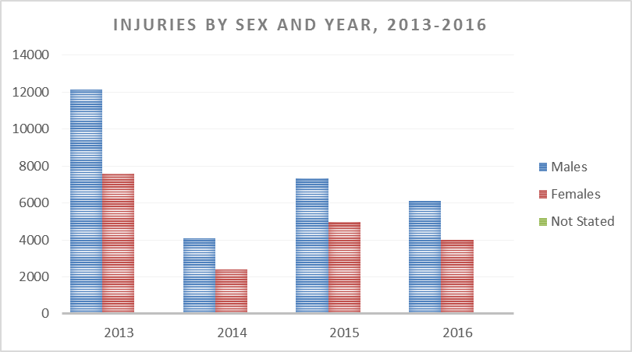
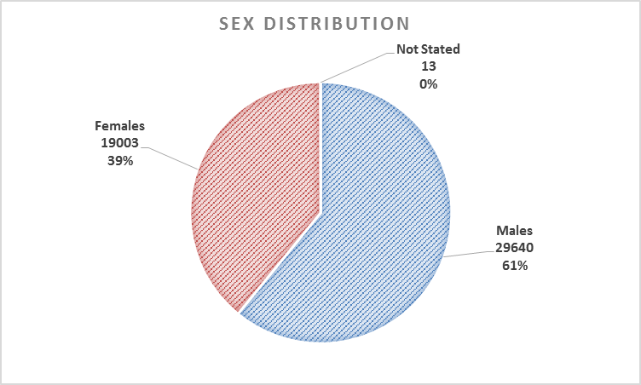

Injuries by activity and Emergency Department, 2013-2016 (Period 01/01/2016 – 05/10/2016)
Activity when injured | Limassol | Larnaca | Pafos | Polis | Kyperounta | Total | % of total
Paid work | 3315 | 796 | 171 | 109 | 56 | 4447 | 9%
Sports | 1038 | 194 | 217 | 80 | 44 | 1573 | 3%
Other | 28958 | 6838 | 2109 | 536 | 397 | 38838 | 80%
Unknown | 222 | 2519 | 520 | 369 | 168 | 3798 | 8%
Total | 33533 | 10347 | 3017 | 1094 | 665 | 48656 | 100%

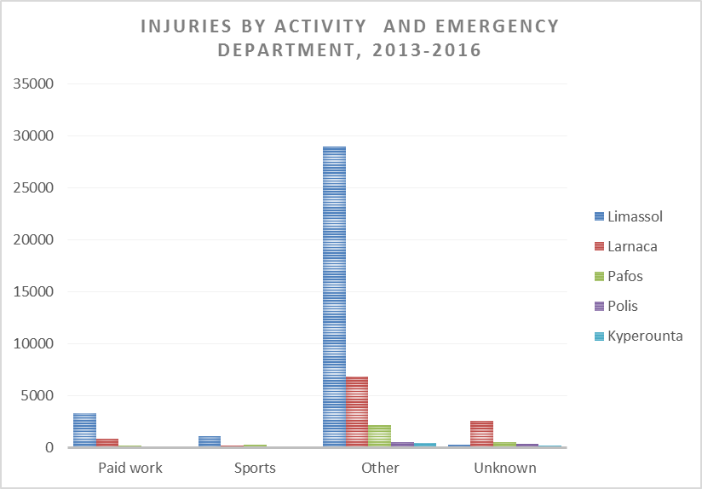

Injuries by mechanism of injury and Emergency Department, 2013-2016 (Period 01/01/2016 – 05/10/2016)
Mechanism of injury | Limassol | Larnaca | Pafos | Polis | Kyperounta | Total
Fall | 29,3% | 6,6% | 3,0% | 0,8% | 0,6% | 40,3%
Other | 12,5% | 4,8% | 0,8% | 0,4% | 0,3% | 18,7%
Road traffic injuries | 13,4% | 4,2% | 0,7% | 0,3% | 0,1% | 18,6%
Cut/pierce | 12,0% | 4,1% | 1,1% | 0,7% | 0,3% | 18,1%
Unknown | 0,2% | 1,3% | 0,3% | 0,1% | 0,1% | 2,0%
Thermal mechanism (Burn/Scald) | 0,9% | 0,3% | 0,1% | 0,0% | 0,0% | 1,5%
Poisoning | 0,7% | 0,1% | 0,0% | 0,0% | 0,0% | 0,9%
Total | 68,9% | 21,3% | 6,2% | 2,2% | 1,4% | 100,0%

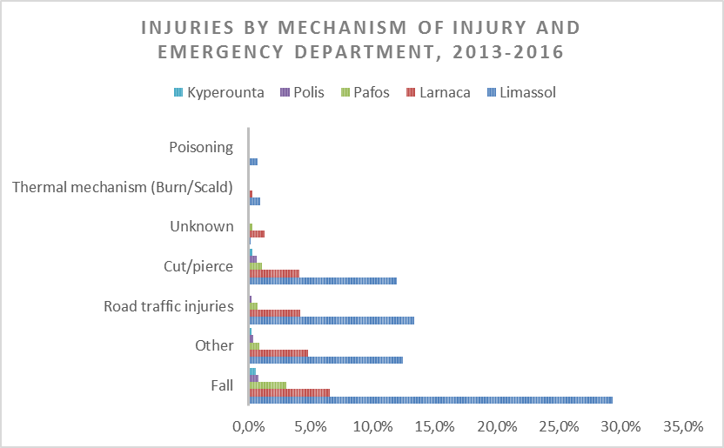
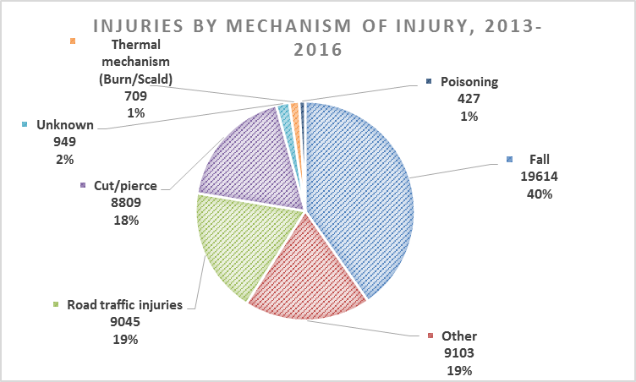
Injuries by location of the injury and Emergency Department, 2013-2016 (Period 01/01/2016 – 05/10/2016)
Location (setting) of the injury | Limassol | Larnaca | Pafos | Polis | Kyperounta | Total
Educational establishment (and surrounding grounds) | 5,0% | 1,0% | 0,5% | 0,1% | 0,1% | 6,6%
Home (incl. garden) | 26,1% | 6,2% | 2,0% | 0,8% | 0,5% | 35,6%
Road (incl. pavement) | 16,8% | 3,7% | 1,6% | 0,4% | 0,2% | 22,7%
Other | 20,8% | 8,9% | 1,2% | 0,8% | 0,5% | 32,1%
Unknown | 0,1% | 1,5% | 1,0% | 0,2% | 0,1% | 2,9%
Total | 68,9% | 21,3% | 6,2% | 2,2% | 1,4% | 100,0%

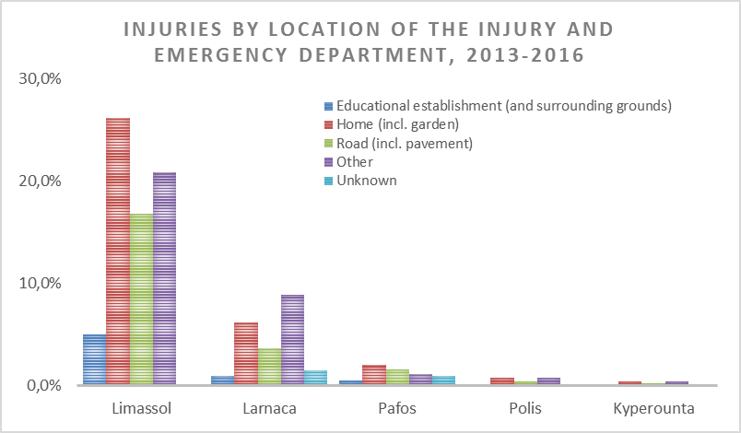
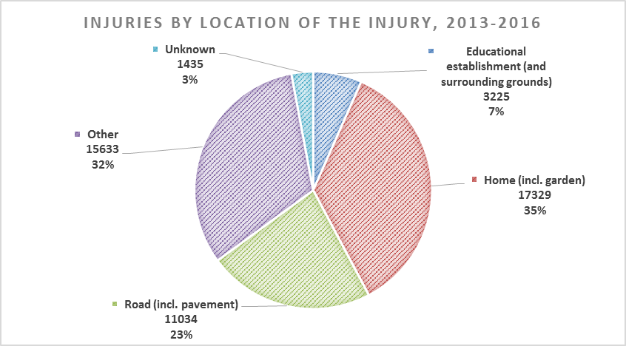

Treatment and follow-up by Emergency Department, 2013-2016 (Period 01/01/2016 – 05/10/2016)
Treatment and follow up | Admitted to this or another hospital or deceased during hospital admittance | Not admitted to hospital | Unknown | Not stated | Total
Limassol | 1,8% | 66,0% | 1,2% | 0,0% | 68,9%
Larnaca | 0,0% | 7,5% | 13,8% | 0,0% | 21,3%
Pafos | 0,6% | 5,3% | 0,3% | 0,0% | 6,2%
Polis | 0,1% | 1,3% | 0,8% | 0,0% | 2,2%
Kyperounta | 0,0% | 0,2% | 0,2% | 1,0% | 1,4%
Total | 2,6% | 80,3% | 16,2% | 1,0% | 100,0%

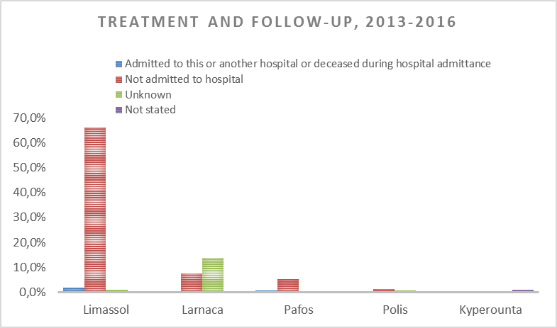
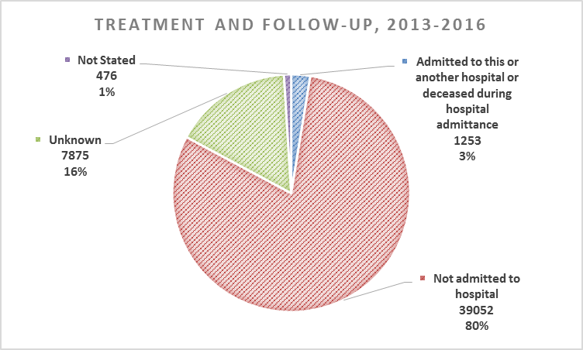
Injuries by nature of injury and Emergency Department, 2013-2016 (Period 01/01/2016 – 05/10/2016)
Nature of injury (Type of injury) 1 | Limassol | Larnaca | Pafos | Polis | Kyperounta | Total | % of total
Burns and scalds | 319 | 66 | 64 | 18 | 10 | 477 | 1,0%
Concussion/brain injury | 307 | 17 | 22 | 28 | 5 | 379 | 0,8%
Contusion/bruise | 4024 | 193 | 882 | 67 | 63 | 5229 | 10,7%
Dislocation/subluxation | 300 | 23 | 63 | 17 | 8 | 411 | 0,8%
Foreign body | 674 | 17 | 27 | 8 | 13 | 739 | 1,5%
Fracture | 1633 | 116 | 203 | 130 | 41 | 2123 | 4,4%
Injury to internal organs | 33 | 3 | 12 | 3 | 3 | 54 | 0,1%
Injury to muscle/tendon/blood vessels/nerves | 340 | 68 | 58 | 30 | 19 | 515 | 1,1%
Multiple injuries | 218 | 18 | 61 | 3 | 5 | 305 | 0,6%
Open wound/abrasion | 6258 | 1322 | 1165 | 552 | 270 | 9567 | 19,7%
Poisoning | 380 | 20 | 25 | 4 | 5 | 434 | 0,9%
Sprain and strain | 3284 | 406 | 204 | 73 | 48 | 4015 | 8,3%
Unknown | 782 | 5412 | 24 | 62 | 70 | 6350 | 13,1%
Other | 14981 | 2666 | 207 | 99 | 105 | 18058 | 37,1%
Total | 33533 | 10347 | 3017 | 1094 | 665 | 48656 | 100,0%

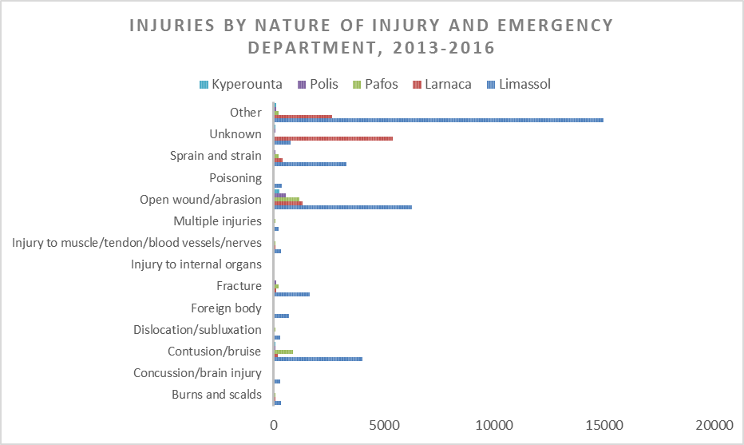
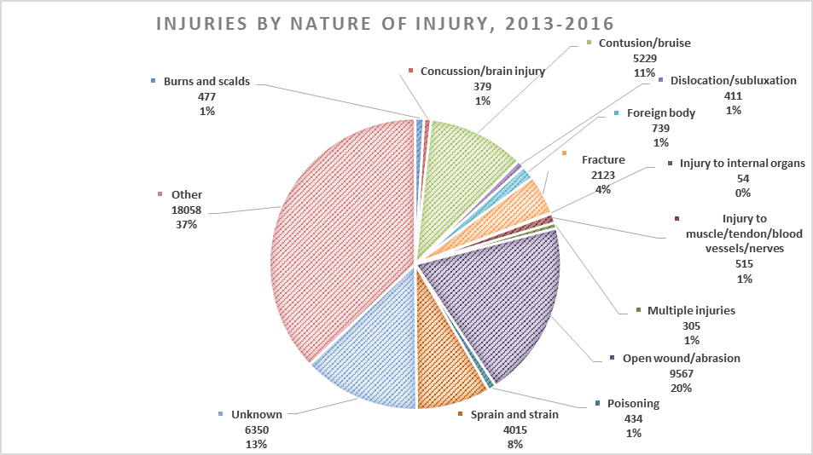

Injuries by nature of injury and Emergency Department, 2013-2016 (in case of a secondary injury)
(Period 01/01/2016 – 05/10/2016)
Nature of injury (Type of injury) 2 | Limassol | Larnaca | Pafos | Polis | Kyperounta | Total | % of total
Burns and scalds | 28 | 52 | 14 | 4 | 5 | 103 | 0,2%
Concussion/brain injury | 18 | 11 | 4 | 5 | 1 | 39 | 0,1%
Contusion/bruise | 341 | 175 | 117 | 16 | 30 | 679 | 1,4%
Dislocation/subluxation | 6 | 21 | 5 | 2 | 2 | 36 | 0,1%
Foreign body | 18 | 8 | 3 |  | 2 | 31 | 0,1%
Fracture | 73 | 114 | 37 | 20 | 12 | 256 | 0,5%
Injury to internal organs | 1 | 1 | 4 | 1 |  | 7 | 0,0%
Injury to muscle/tendon/blood vessels/nerves | 60 | 11 | 8 | 6 | 6 | 91 | 0,2%
Multiple injuries | 4 | 5 | 7 | 2 |  | 18 | 0,0%
Open wound/abrasion | 341 | 1194 | 105 | 86 | 85 | 1811 | 3,7%
Other | 1744 | 100 | 35 | 9 | 11 | 1899 | 3,9%
Poisoning | 15 | 6 | 6 |  | 1 | 28 | 0,1%
Sprain and strain | 259 | 372 | 15 | 3 | 10 | 659 | 1,4%
Unknown | 312 | 107 | 96 | 56 | 44 | 615 | 1,3%
Non applicable | 30313 | 8170 | 2561 | 884 | 456 | 42384 | 87,1%
Total | 33533 | 10347 | 3017 | 1094 | 665 | 48656 | 100%

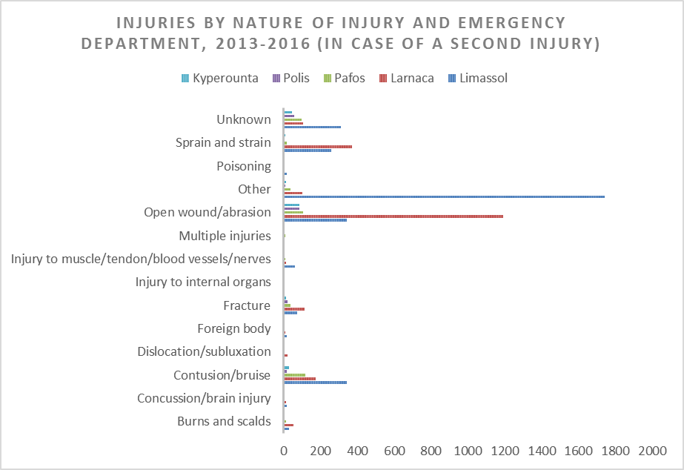

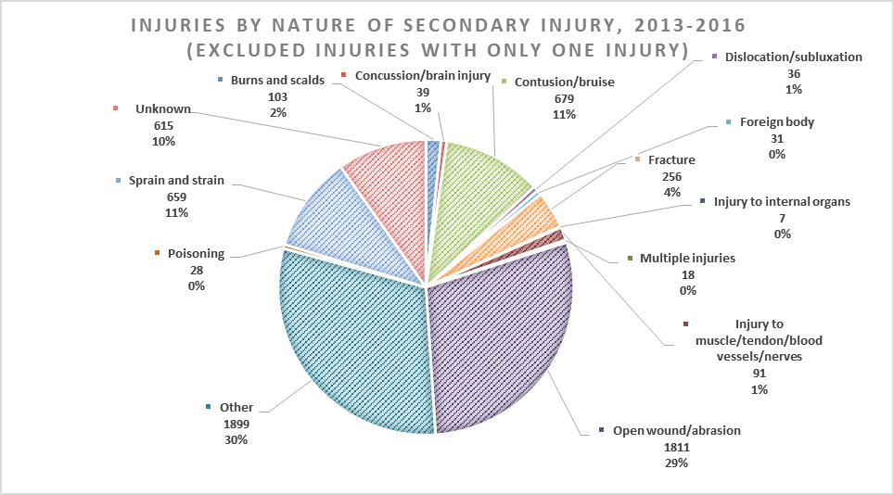

Part of the body injured 1 by Emergency Department, 2013-2016 (Period 01/01/2016 – 05/10/2016)
Part of the body injured 1 | Limassol | Larnaca | Pafos | Polis | Kyperounta | Total | % of total
Abdominal wall | 66 | 5 | 18 | 3 | 5 | 97 | 0,2%
Ankle | 1086 | 66 | 139 | 65 | 29 | 1385 | 2,8%
Chest wall | 374 |  | 75 | 20 | 15 | 484 | 1,0%
Elbow | 132 | 11 | 64 | 27 | 15 | 249 | 0,5%
Eye | 710 | 51 | 35 | 6 | 15 | 817 | 1,7%
Face (excl. eye) | 1139 | 217 | 218 | 83 | 37 | 1694 | 3,5%
Fingers | 1945 | 361 | 297 | 137 | 62 | 2802 | 5,8%
Foot | 4122 | 1138 | 261 | 73 | 46 | 5640 | 11,6%
Hand | 3688 | 1202 | 284 | 113 | 80 | 5367 | 11,0%
Head/skull | 2532 | 813 | 510 | 203 | 128 | 4186 | 8,6%
Hip | 134 | 3 | 69 | 21 | 7 | 234 | 0,5%
Internal organs | 205 |  |  |  |  | 205 | 0,4%
Knee | 424 | 58 | 142 | 42 | 41 | 707 | 1,5%
Lower arm | 172 | 4 | 76 | 19 | 2 | 273 | 0,6%
Lower leg | 45 | 11 | 113 | 26 | 8 | 203 | 0,4%
Multiple body parts | 1093 | 94 | 86 | 4 | 10 | 1287 | 2,6%
Neck | 784 | 14 | 38 | 19 | 11 | 866 | 1,8%
Pelvis | 169 | 4 | 17 | 8 | 6 | 204 | 0,4%
Thoracic/lumbar spine | 622 | 3 | 133 | 33 | 14 | 805 | 1,7%
Toes | 384 | 38 | 79 | 24 | 11 | 536 | 1,1%
Upper arm/shoulder | 486 | 10 | 120 | 36 | 16 | 668 | 1,4%
Upper leg | 40 | 3 | 21 | 11 | 9 | 84 | 0,2%
Wrist | 372 | 32 | 71 | 53 | 31 | 559 | 1,1%
Other | 12005 | 1590 | 107 | 36 | 21 | 13759 | 28,3%
Unknown | 804 | 4619 | 44 | 32 | 46 | 5545 | 11,4%
Total | 33533 | 10347 | 3017 | 1094 | 665 | 48656 | 100,0%

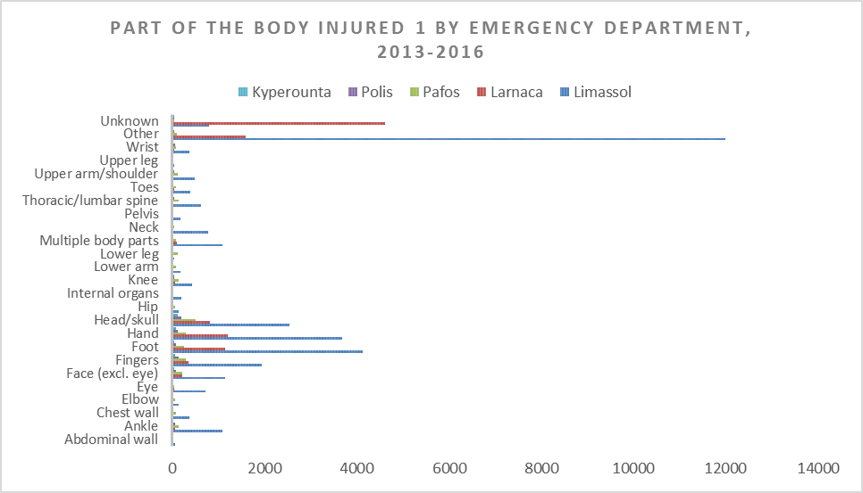

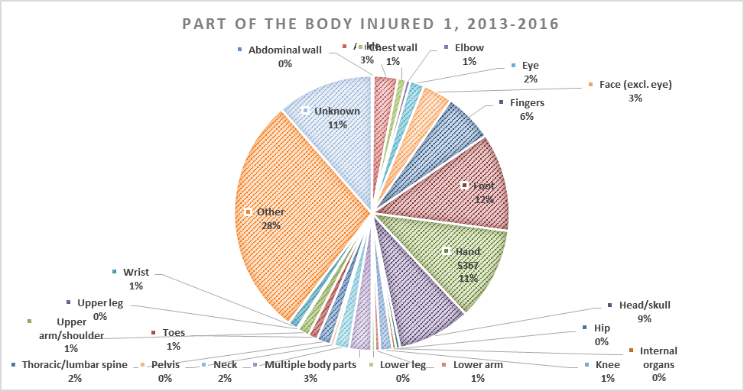

Part of the body injured 2, by Emergency Department, 2013-2016 (Period 01/01/2016 – 05/10/2016)
Part of the body injured 2 | Limassol | Larnaca | Pafos | Polis | Kyperounta | Total | % of total
Abdominal wall | 6 | 3 | 4 | 3 | 2 | 18 | 0,0%
Ankle | 37 | 33 | 9 | 6 | 5 | 90 | 0,2%
Chest wall | 28 |  | 8 | 8 | 3 | 47 | 0,1%
Elbow | 15 | 9 | 7 | 12 | 3 | 46 | 0,1%
Eye | 44 | 26 | 5 |  | 6 | 81 | 0,2%
Face (excl. eye) | 70 | 189 | 24 | 9 | 8 | 300 | 0,6%
Fingers | 84 | 332 | 24 | 10 | 17 | 467 | 1,0%
Foot | 294 | 855 | 22 | 10 | 22 | 1203 | 2,5%
Hand | 320 | 815 | 30 | 14 | 26 | 1205 | 2,5%
Head/skull | 139 | 598 | 23 | 14 | 42 | 816 | 1,7%
Hip | 7 | 1 | 9 | 3 | 4 | 24 | 0,0%
Internal organs | 2 | 1 | 2 | 1 |  | 6 | 0,0%
Knee | 25 | 43 | 25 | 12 | 18 | 123 | 0,3%
Lower arm | 6 | 4 | 9 | 2 | 1 | 22 | 0,0%
Lower leg | 4 | 4 | 28 | 4 | 2 | 42 | 0,1%
Multiple body parts | 68 | 13 | 3 | 1 |  | 85 | 0,2%
Neck | 53 | 9 | 8 | 4 | 7 | 81 | 0,2%
Pelvis | 25 | 3 | 4 | 3 | 4 | 39 | 0,1%
Thoracic/lumbar spine | 54 | 3 | 23 | 3 | 3 | 86 | 0,2%
Toes | 21 | 40 | 8 | 2 | 3 | 74 | 0,2%
Unknown | 248 | 836 | 51 | 54 | 36 | 1225 | 2,5%
Upper arm/shoulder | 37 | 4 | 21 | 9 | 4 | 75 | 0,2%
Upper leg | 5 | 1 | 2 |  | 6 | 14 | 0,0%
Wrist | 19 | 16 | 51 | 8 | 4 | 98 | 0,2%
Other | 1905 | 86 | 16 | 9 | 9 | 2025 | 4,2%
Non applicable | 30017 | 6423 | 2601 | 893 | 430 | 40364 | 83,0%
Total | 33533 | 10347 | 3017 | 1094 | 665 | 48656 | 100,0%

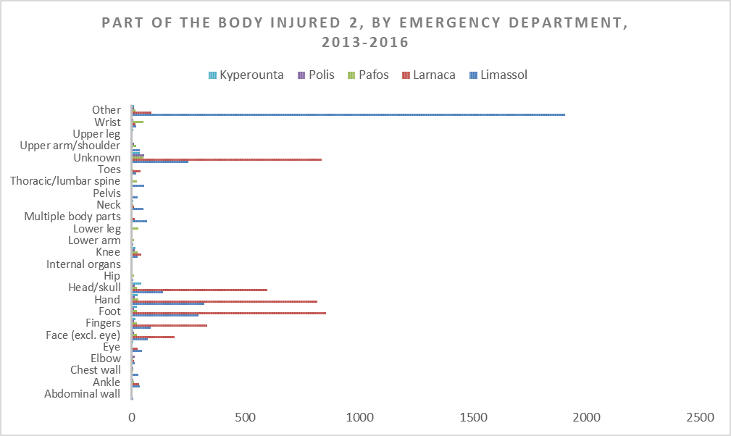
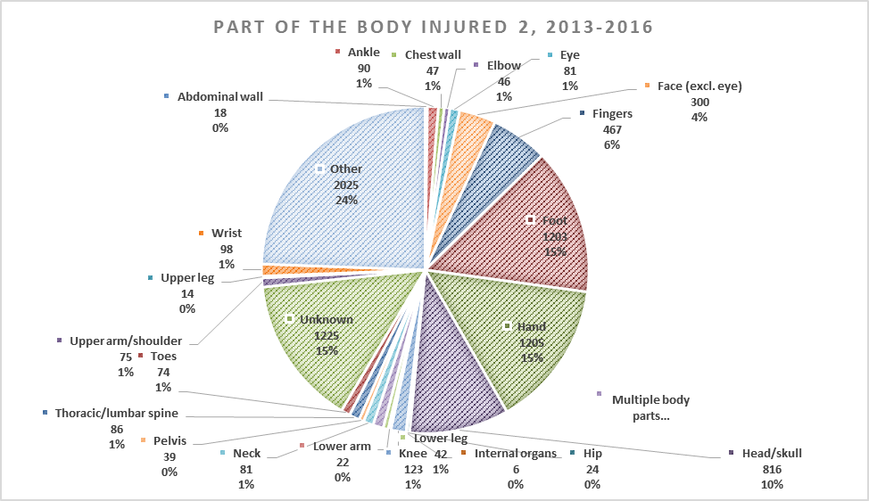

Injuries by intent and Emergency Department, 2013-2016 (Period 01/01/2016 – 05/10/2016)

Emergency Department / Intent | Accidental (unintentional) injury | Assault related injury | Deliberate (intentional) self-harm | Unknown intent | Total
Limassol | 93,16% | 5,93% | 0,45% | 0,46% | 100,0%
Larnaca | 82,64% | 7,51% | 0,64% | 9,21% | 100,0%
Pafos | 89,72% | 3,58% | 0,80% | 5,90% | 100,0%
Polis | 86,56% | 3,11% | 1,46% | 8,87% | 100,0%
Kyperounta | 84,96% | 2,11% | 1,80% | 11,13% | 100,0%
Total | 90,45% | 6,00% | 0,55% | 2,99% | 100,0%

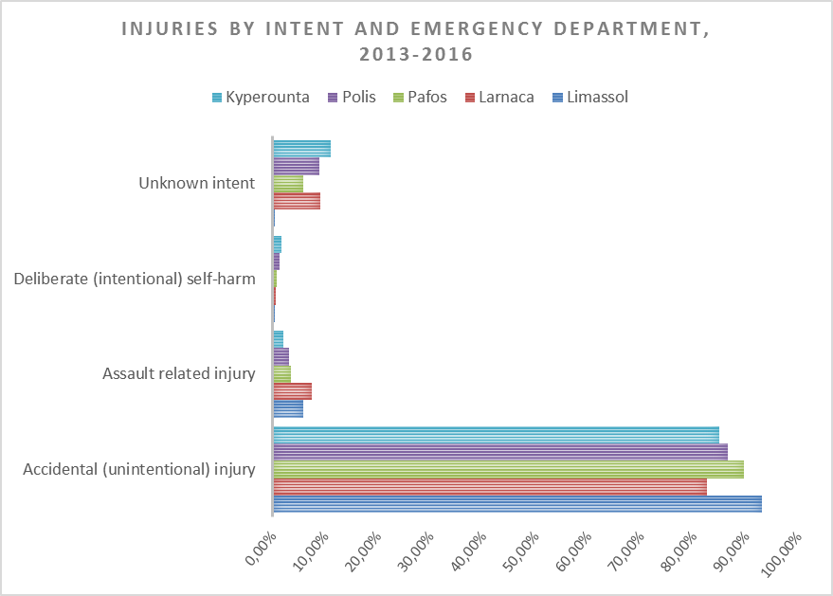

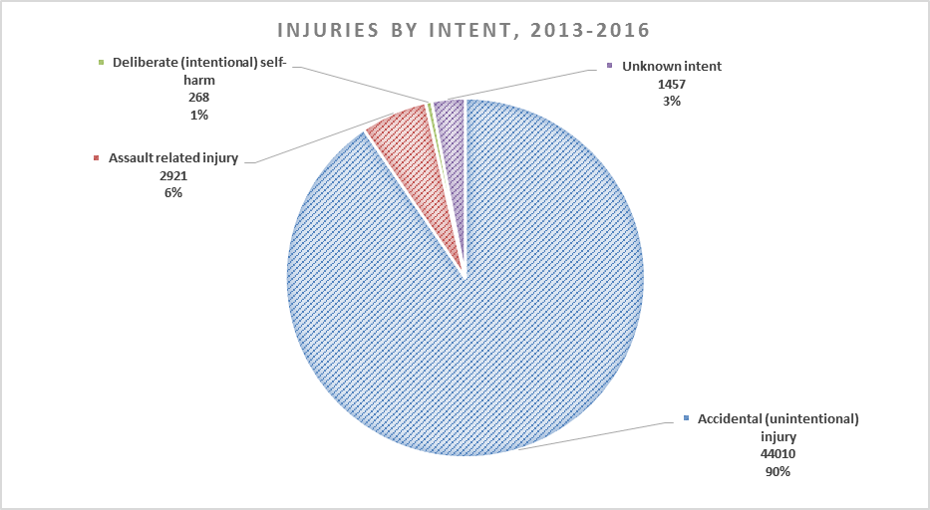

87.1% of the total number of injuries attended at the Emergency Departments of the five public hospitals did not have any secondary injury.

